Task | Story Points | Delivered by | Estimation | Remarks
Database | 3 | Zorrilla | 2 days | 0%
Account - CRUD | 5 | Zorrilla | 2 days | 0%
Account - UI | 3 | Gozar | 1 day | Done
Document List Interface | 3 | Limon | 2 days | Done
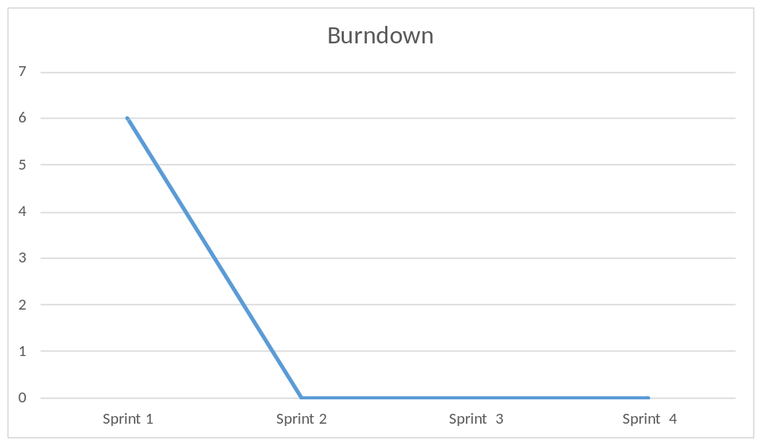

What went well?
The interface
What went wrong?
Zorrilla did nothing
What to improve
Everything

